Scan to check out the Business Dept web page
Columbus North High School
B
U
S
I
N
E
S
S

D
E
P
A
R
T
M
E
N
T
To receive a technical honors diploma you must earn 6 business credits in the following classes:
- Introduction to Accounting
- Advanced Accounting
- Principles of Business Management

YEARLONG CLASSES
TECHNICAL HONORS DIPLOMA PATHWAY

SEMESTER CLASSES

* Dual Credit Available
** Quantitative Reasoning
- Introduction to Accounting
- Advanced Accounting **
- Principles of Marketing *
- Principles of Business Management *

- Business Law & Ethics *
- Digital Applications & Responsibilities 1, 2 *
- Global Economics
- Introduction to Business 1, 2
- Sports and Entertainment Marketing
- Personal Financial Responsibility **
- Career Information and Exploration

Suggested class schedule:
Freshman | Sophomore | Junior | Senior
Digital Applications & Responsibilities 1 and 2  OR  Introduction to Business 1 and 2 | Introduction to Accounting  AND/OR  Principles of Marketing | Sports and Entertainment Marketing  Advanced Accounting  Personal Financial Responsibility | Global Economics  Career Information & Exploration  Principles of Business Management  Business Law & Ethics

Possible Careers | Fun Activities
Bookkeeper / Accounting Clerk  Finance or Marketing Manager  Entrepreneur  Human Resources Manager  General Manager  Lawyer  CPA or CMA (Certified Public Accountant or Management Accountant)  Financial Advisor | Business Simulations  Mock Trials and Judicial Court Field Trip  Maverick Challenge Competition $  Innovate WithIN Competition $  BPA and DECA Clubs  Guest Speakers  Microsoft Office Certification  Certificate of Merit and Outstanding Business Student Awards
Why take Business Classes?

Meet Our Business Teachers!

Mrs. Daily
Bachelor’s of Science in Management with a specialty in Human Resources, IUPUC
Master's degree Secondary Education, Indiana University
Master’s of Business Administration, IUPUC
Classes: Principles of Business Management, Introduction to Accounting,
Advanced Accounting and Preparing for College and Careers

Mr. Campbell
Bachelor’s of Arts in Economics, Indiana University
Master’s of Arts in Teaching, University of Indianapolis
Classes: Digital Applications and Responsibility, Global Economics, Career Information and Exploration (Senior Project Class), Principles of Marketing

Mr. Seavers
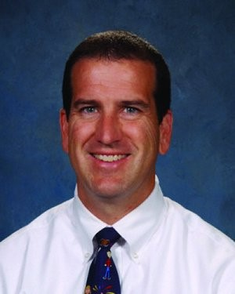
Bachelor’s of Science in Business and
Master’s degree in Secondary education, Ball State University
Classes: Personal Finance Responsibility, Career Information and Exploration (Senior Project Class) and Business Law and Ethics

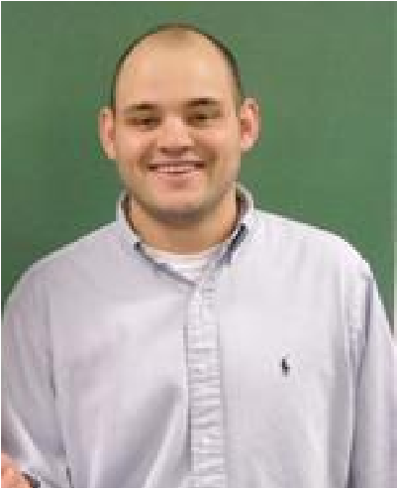
Mr. Dunn
Bachelor’s of Business Administration and
Bachelor’s of Business Education, Indiana State University
Master’s in Business Management, Indiana Wesleyan University
Classes: Introduction to Business, Sports and Entertainment Marketing,
Preparing for College and Careers

